
Claim Ref.: INL/
Vehicle Transit
Condition Report
Date:
Make/Model:
Reg. No.:
Please satisfy yourself that the condition of the vehicle matches the description on this form.

X ____________________________ Owners signature or their official
I agree with the vehicles pre of transit condition as shown below.

Certificate No. | Vehicle Delivered to Remover | NO / YES
Insurers Contact Phone No. | Customer Present | NO / YES

Company Use | Start of Transit

Point of Damage – marked by an ‘X’
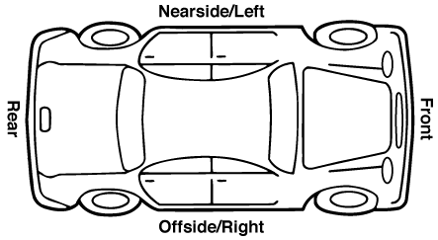
Exterior Interior
Baby Seat
Yes - No -

MPV Seats
Yes - No -

Description of Damage (location/item/type): ___________________________________________________________
Location | Item |  |  |  | Type
Nearside / Left Front | Bonnet | Bumper | Lights | Parcel Shelf | Scratch | Burn
Offside / Right Rear | Wing | Glass | Mirror | Spare Wheel | Dent | Tear
 | Door | Seat | Wheel Trim | Tools | Chip | Missing
 | Roof | Radio | Wheel Rim |  | Crack
 | Boot | Carpet | Aerial
Company Rep. Initials: | Date: |  |  |  | If damaged, IRF No.:

Company Use | End of Transit

Point of Damage – marked by an ‘X’
Exterior Interior
Baby Seat
Yes - No -

MPV Seats
Yes - No -

Description of Damage (location/item/type): ___________________________________________________________
Location | Item |  |  |  | Type
Nearside / Left Front | Bonnet | Bumper | Lights | Parcel Shelf | Scratch | Burn
Offside / Right Rear | Wing | Glass | Mirror | Spare Wheel | Dent | Tear
 | Door | Seat | Wheel Trim | Tools | Chip | Missing
 | Roof | Radio | Wheel Rim |  | Crack
 | Boot | Carpet | Aerial

Owners Signature:_________________________________________________________________________ Date: _______________________
I declare that the information provided is true and properly completed to the best of my knowledge and belief.
Please return to Baker & Co. Fax: 01608 664781 E-mail: claims@bakerand.co.uk Tel: 01608 664777
At end of transit responsibility period, if available. If new damage is found, the shipper must complete an Incident Report Form.

Distribution: Check-out Distribution: Pink – Station / White - Shipper / Blue – Glove Box


